Index

1. Acknowledgement

2. Introduction
- Problem Statement
- Objectives of the Project
- Scope of the Project

3. System Development Life Cycle (SDLC)
- Requirement Analysis
- Design
- Implementation
- Testing
- Deployment & Maintenance

4. System Design
- Flowchart / Workflow
- Module Description
- Database Design Overview

5. User Interface Design
- GUI Design
- CLI Design

6. Implementation

6.1 Source Code Structure

6.2 Libraries Used
- Pre-defined Libraries
- User-defined Modules

7. Database Design
- Table Structures
- Relationships
- Sample Records

8. Testing
- Test Cases
- Output Screenshots
- Error Handling

9. Demonstration / Output
- Screens
- Sample Runs

10. Conclusion

11. Bibliography

1. Acknowledgement

2. Introduction

Problem Statement
Traditional manual railway management systems often suffer from significant drawbacks, including data redundancy, human error in record-keeping, and slow processing times for critical tasks like ticket booking and cancellation. Based on the project implementation, several specific challenges are addressed:
- Manual Fare and Refund Calculation: Manual calculation of refunds is prone to error; the code automates this by calculating a 80% refund of the original fare upon cancellation.
- Data Fragmentation: Information regarding trains, passengers, and bookings is often stored in disparate locations. This system centralizes all records using a MySQL database named "RMS".
- Administrative Security: Without a structured interface, database records are vulnerable to unauthorized changes. This project implements a password-protected CLI to ensure only authorized administrators can modify core train and passenger data.
- Reporting Difficulties: Extracting specific data from a database for offline viewing or printing can be difficult for non-technical users; the system solves this with an automated text export feature.

Objectives of the Project
The primary objective is to create a robust, automated environment for railway operations. Specific objectives include:
- Database Automation: To programmatically create and maintain relational tables for Users, Trains, Passengers, Bookings, and Cancellations.
- Dual-Interface Development: To provide a user-friendly Graphical User Interface (GUI) for general navigation and a Command Line Interface (CLI) for rapid administrative tasks.
- Streamlined Ticketing: To automate the booking process by generating and storing PNR numbers, journey details, and fare information.
- Efficient Record Management: To enable administrators to perform CRUD (Create, Read, Update, Delete) operations on train schedules and passenger lists through a dedicated CLI.
- Automated Exporting: To allow users to generate formatted reports of train and passenger data in .txt format at the click of a button.

Scope of the Project
The scope of the RMS project encompasses the functional and administrative requirements of a modern railway hub:
- Authentication & Security: Includes user registration and login functionality within the GUI. The Admin CLI is further secured by a password ("admin123").
- Train & Passenger Management: The system handles detailed scheduling (Train ID, Name, Source, Destination, Day) and passenger demographics (ID, Name, Age, Gender, Phone).
- Transaction Processing: Full support for booking tickets and processing cancellations, including automatic deletion of booking records once a ticket is cancelled and moved to the cancellation log.
- Reporting & Archiving: The system can fetch live data from the TRAIN and PASSENGER tables and export it into readable files like table_data_train.txt and table_data_pasenger.txt.
- Database Integrity: Ensuring referential integrity through foreign keys, such as linking Booking records to specific TrainID and PassengerID entries.

3. System Development Life Cycle (SDLC)

3.1 Design
During the design phase, the focus was on creating a logical structure for data and a seamless navigation flow between the GUI and CLI components.
- Database Design: A relational schema was designed to minimize redundancy. The system uses primary keys (like TrainID and PNR_No) and foreign keys to link bookings to specific trains and passengers.
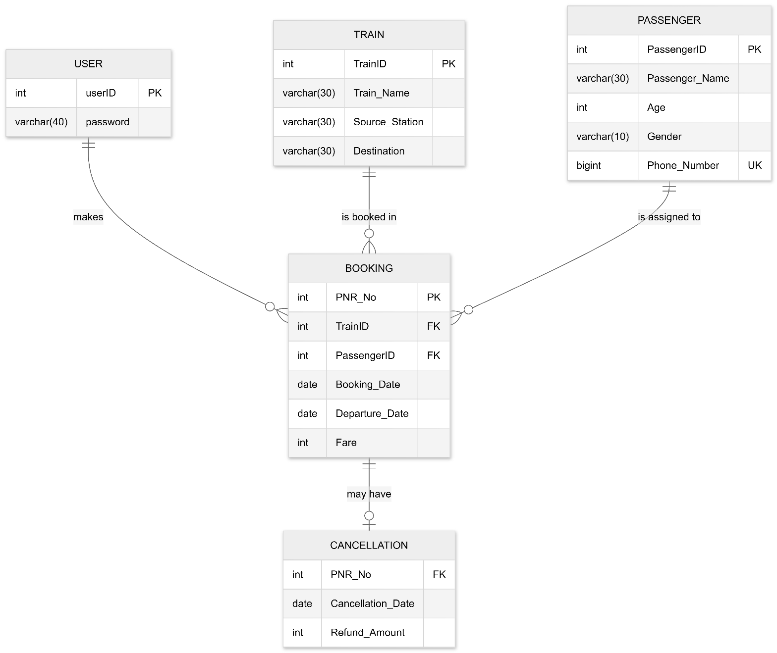
Figure 1: ER Diagram

- Architectural Design: The system was split into a Frontend (Tkinter GUI), a Logical Layer (Modular Python files for business logic), and a Backend (MySQL Database).

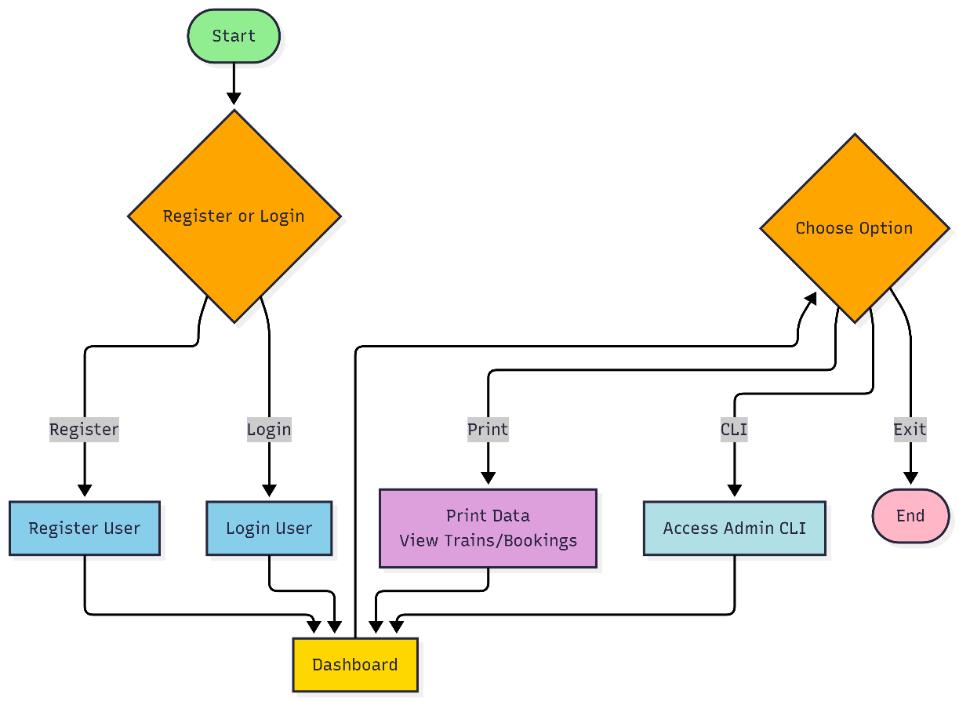
Figure 2: System Architecture Flowchart

3.2 Implementation
The implementation phase involved translating the design into executable Python code using a modular approach.
- Database Connectivity (db.py): Established the connection string using mysql.connector with parameters for host, user, and password.
- Table Setup (tables.py): Created automated scripts to generate the RMS database and all required tables if they do not already exist, ensuring the environment is ready upon first launch.
- Administrative Logic (admin_cli.py): Developed a text-based interface for heavy data management. This module imports functions from train.py, passengers.py, and bookings.py to allow administrators to add or modify records directly.
- Export Logic (printer.py): Implemented a reporting feature that uses Python's file handling (open(), write()) to format database rows into a aligned text table and launch it automatically in the system's default text editor.
3.3 Testing
Testing was conducted iteratively to ensure data integrity and a smooth user experience.
- Unit Testing: Individual functions like add_train() and cancel_ticket() were tested for edge cases (e.g., entering a non-existent PNR).
- Validation Testing: The system was checked to ensure that optional fields (like Age or Phone Number) are correctly handled as NULL in the database rather than causing a crash.
- Security Testing: Verified that the Admin CLI remains inaccessible without the correct password ("admin123").
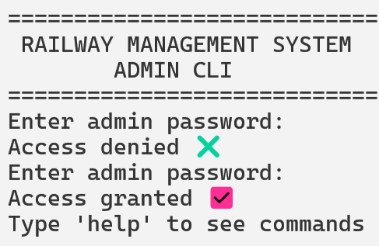
Figure 3: Screenshot - Admin CLI Authentication

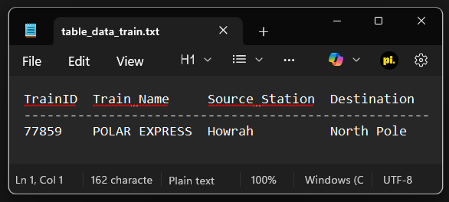
Figure 4: Screenshot - Successful Data Export

3.4 Deployment & Maintenance
The system is deployed locally. For maintenance, the db.py file allows for easy modification of database credentials if the system is moved to a different server. The modular structure of the code allows for future updates (like adding a "Seat Availability" feature) without rewriting the core GUI logic.
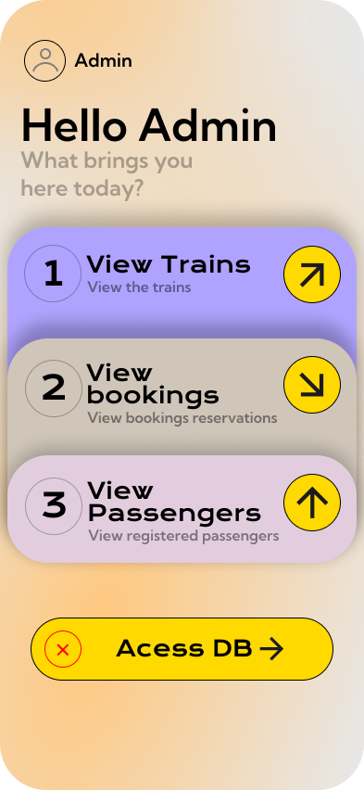

4. System Design

4.1 Flowchart / Workflow
The system operates on a multi-layered workflow where the user interacts with the GUI for high-level tasks and the Admin CLI for data-intensive management.
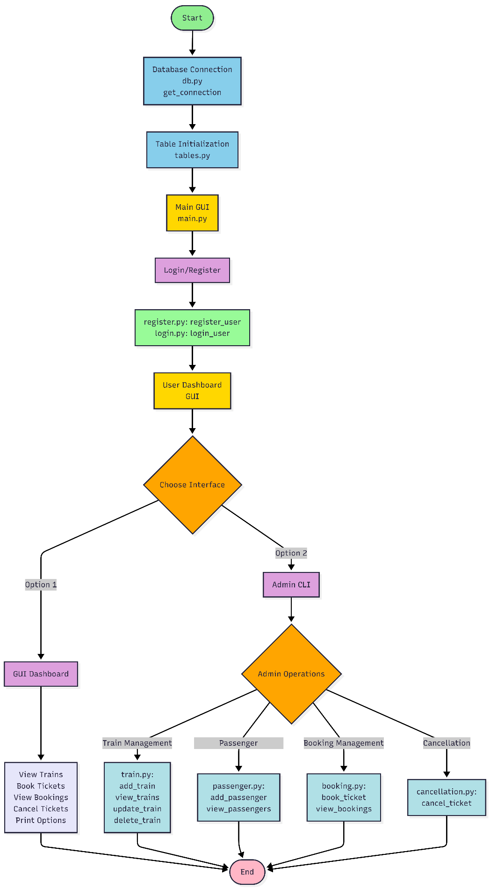
Figure 5: Main Application Workflow
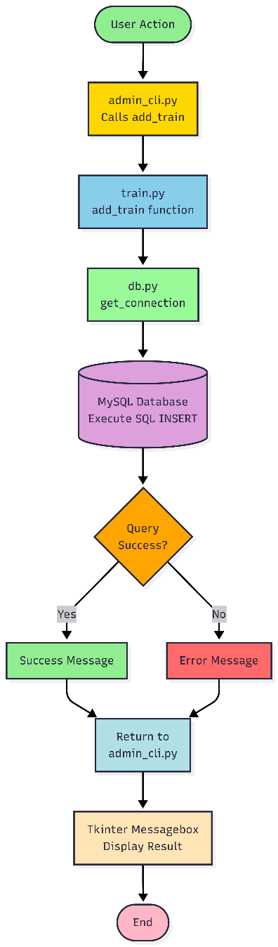
Figure 6: Internal Data Flow

4.2 Module Description
The project is divided into several Python modules, each with a specific responsibility:
- main.py: The "Brain" of the GUI. It manages the Tkinter window, handles frame switching (Welcome, Login, Dashboard), and initializes the database tables upon startup.
- admin_cli.py: Provides a robust command-line environment for administrators. It supports nested menus for Trains, Passengers, Bookings, and Cancellations, using keywords or numeric shortcuts.
- db.py: The database connector. It abstracts the connection details (host, user, password) and provides the get_connection() function used by all other modules.
- tables.py: A setup utility. It contains SQL CREATE TABLE statements for all five entities, ensuring that the database schema is consistent across different machines.
- train.py: Dedicated to the Train table. It contains logic for adding new schedules, updating existing routes, deleting trains, and viewing the full schedule.
- passengers.py: Manages the Passenger table. It handles the registration of passenger demographics and ensures data types (like Phone Number as a BigInt) are handled correctly.
- bookings.py & cancellation.py: These modules handle the transactional logic. bookings.py creates the link between trains and passengers, while cancellation.py calculates refunds and moves records from the active booking list to the cancellation log.
- printer.py: The reporting engine. It fetches raw SQL data and uses string formatting to create aligned text reports, which are then automatically opened in the system's default text editor (Notepad).

4.3 Database Design Overview
The system uses a relational database model to ensure data integrity and minimize redundancy.
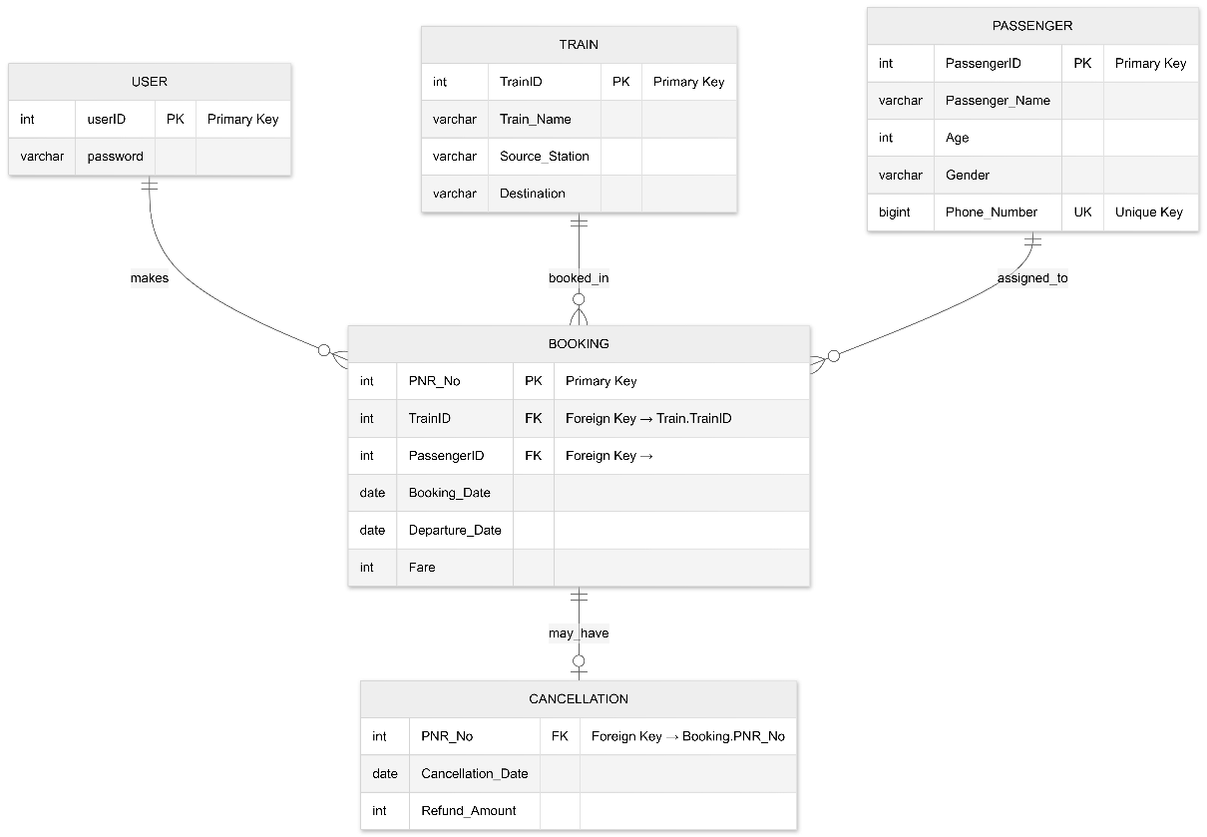
Figure 7: Database Schema Diagram
- Integrity Rules:
  - Cascading Logic: While the code manually handles deletion (e.g., removing a booking when a ticket is cancelled), the database design enforces that a PNR cannot be cancelled unless it first exists in the Booking table.
  - Data Constraints: Fare and Age are protected by CHECK constraints (e.g., Fare >= 0) to prevent logical errors in financial data.
  - Unique Identifiers: Fields like Phone_Number and UserID are marked as UNIQUE or PRIMARY KEY to prevent duplicate account creation.

5. User Interface Design

5.1 GUI Design (Graphical User Interface)
The GUI is designed to be visually engaging and intuitive, using the Tkinter library. It follows a "Single Window, Multiple Frames" architecture where the application switches between different views without opening new windows.
- Design Language: The interface uses high-quality background images (via tk.Canvas) and custom-designed image buttons to create a modern look compared to standard grey UI elements.
- Key Components:
  - Welcome Page: The entry point featuring the project title and navigation buttons for new and returning users.
  - Authentication (Register/Login): Secure frames where users enter credentials. These pages interact with the user table in MySQL.
  - Dashboard Page: The central hub for logged-in users. It features a layout with functional icons for:
    - Exporting Data: Buttons to trigger the text-based reporting system.
    - Administrative Access: A special button to launch the Admin CLI.
    - Logout/Exit: Navigation back to the home screen.

Figure 8: Dashboard Page

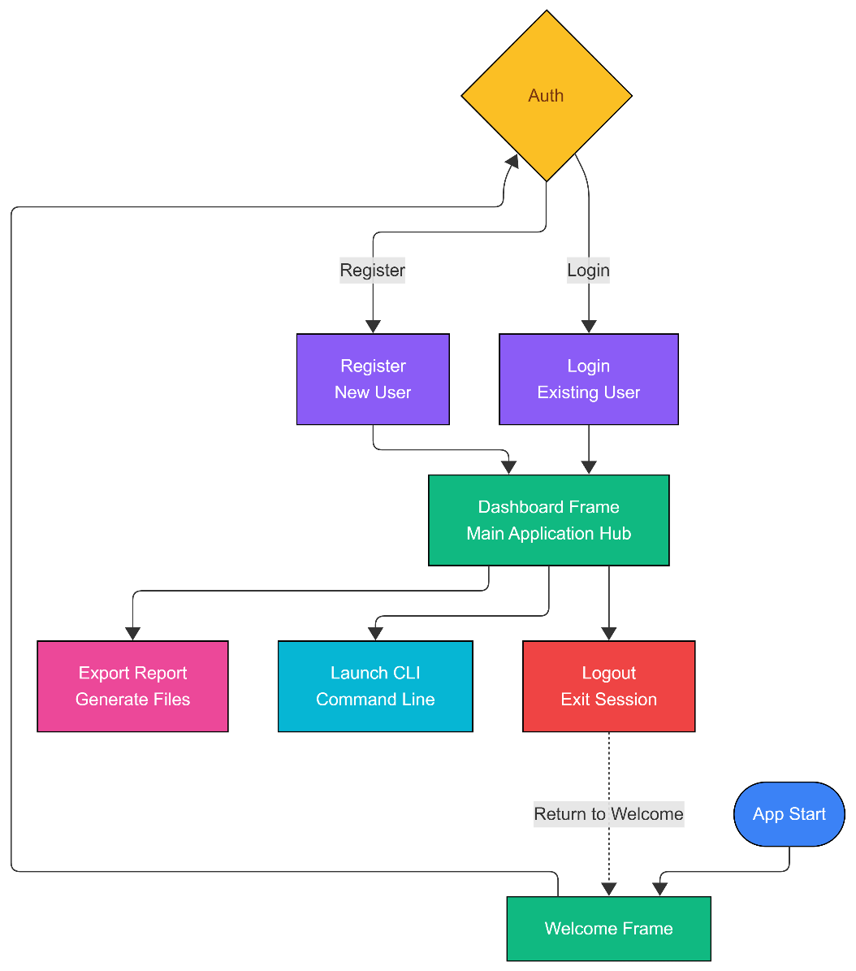
Figure 9: GUI Navigation Flowchart

5.2 CLI Design (Command Line Interface)
The Admin CLI (admin_cli.py) is a powerful, text-based environment intended for rapid data entry and management by station administrators.
- Security Layer: Upon launching, the CLI immediately prompts for an admin password using the getpass library (which hides the characters as they are typed). Access is only granted if the password matches "admin123".
- Menu Structure: The CLI uses a persistent while True loop to keep the session active. It features a hierarchical menu system:
  - Level 1 (Main Menu): Choices for Trains, Passengers, Cancellations, or Bookings.
  - Level 2 (Sub-Menus): Specific actions for each category (Add, Update, Delete, View).
- Command Versatility: The system is designed to be flexible; it accepts both numeric inputs (e.g., 1) and keyword commands (e.g., trains or add) to cater to different user preferences.
- Feedback Mechanism: After every operation, the CLI provides text-based feedback (e.g., "Access granted...", "Fetching records...") and requires a "Press Enter to continue" acknowledgment to prevent the screen from clearing before the user can read the results.

Figure 10: Admin CLI Menu

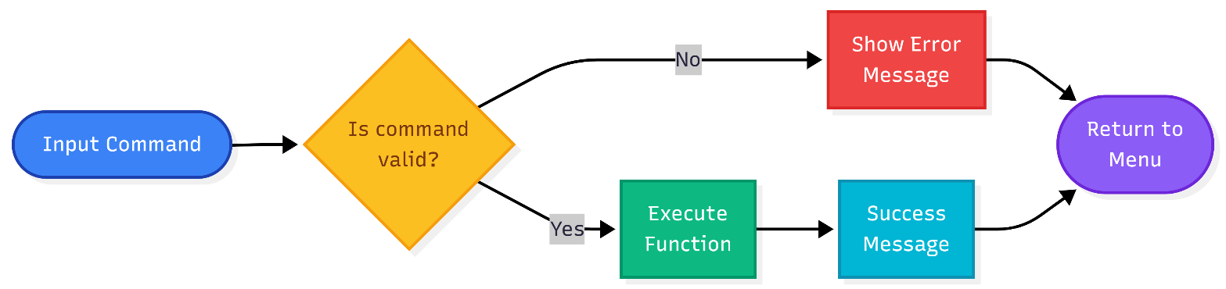
Figure 11: CLI Input Validation Flow

6. Implementation

6.1 Source Code Structure
The project is built using a Modular Architecture. Instead of a single monolithic script, the logic is distributed across specialized files. This makes the system easier to debug, maintain, and scale.
- Entry Point (main.py): Acts as the orchestrator. it initializes the GUI and handles the transition between different application states (Login, Registration, Dashboard).
- Database Configuration (db.py & tables.py): These modules isolate the backend setup. db.py handles the physical connection to the MySQL server, while tables.py defines the relational schema.
- Functional Logic Layer:
  - train.py: Logic for scheduling and managing train routes.
  - passengers.py: Logic for handling passenger profiles.
  - bookings.py: Logic for the ticketing process.
  - cancellation.py: Logic for processing refunds and removing records.
- Reporting Utility (printer.py): A standalone utility focused on data extraction and file I/O formatting.
- Administrative Interface (admin_cli.py): A separate entry point for power users, importing functional logic into a text-based environment.

6.2 Libraries Used
The system leverages a mix of Python's standard library and external packages to provide a rich user experience and persistent data storage.

Pre-defined Libraries
- tkinter: Used for creating the Graphical User Interface, including windows, canvases, and message boxes.
- mysql.connector: The driver used to bridge the Python application with the MySQL database.
- subprocess: Specifically used in main.py to launch the admin_cli.py script as a separate process from the GUI.
- getpass: Used in the Admin CLI to allow secure password entry where characters are hidden from the screen.
- datetime: Used to fetch current timestamps for ticket cancellations.
- os: Used to interact with the operating system, such as clearing the terminal screen or automatically opening exported text files in Notepad.

User-defined Modules
- db: Provides get_connection() to standardize database access across all files.
- tables: Contains functions like create_all_tables() which are called at every app startup to ensure environment readiness.
- train, passengers, bookings, cancellation: These modules encapsulate the "Business Logic" of the railway system.
- printer: Encapsulates the logic for converting SQL result sets into formatted, human-readable text documents.

6.3 Source Code
6.3.1 main.py
import tkinter as tk
import subprocess
import sys
from auth.register import register_user
from auth.login import login_user
from printer import *
from db import create_RMS
from tables import create_all_tables
class App(tk.Tk):
def __init__(self):
super().__init__()

self.title("Railway management system")
self.geometry("390x844")
self.resizable(False,False)
container = tk.Frame(self)
container.pack(fill="both", expand=True)

self.frames = {}

for Page in (WelcomePage, RegisterPage, LoginPage, DashboardPage):
frame = Page(container, self)
self.frames[Page] = frame
frame.grid(row=0, column=0, sticky="nsew")

self.show_frame(WelcomePage)

def show_frame(self, page):
self.frames[page].tkraise()

class WelcomePage(tk.Frame):
def __init__(self, parent, controller):
super().__init__(parent)

create_all_tables()

self.canvas = tk.Canvas(self, width=390, height=844)
self.canvas.pack(fill="both", expand=True)

self.bg_image = tk.PhotoImage(file="assets/Welcome/bg.png")
self.register_img = tk.PhotoImage(file="assets/Welcome/btn_register.png")
self.login_img = tk.PhotoImage(file="assets/Welcome/btn_login.png")
self.hero_img = tk.PhotoImage(file="assets/Welcome/Hero.png")

self.canvas.create_image(195, 422, image=self.bg_image)
self.canvas.create_image(205, 535, image=self.hero_img)

# Register button (image only)
reg_id = self.canvas.create_image(140, 730, image=self.register_img)
self.canvas.tag_bind(reg_id, "<Button-1>", lambda event: controller.show_frame(RegisterPage))

# Login button (image only)
log_id = self.canvas.create_image(320, 730, image=self.login_img)
self.canvas.tag_bind(log_id, "<Button-1>", lambda event: controller.show_frame(LoginPage))

class RegisterPage(tk.Frame):
def __init__(self, parent, controller):
super().__init__(parent)
self.controller = controller # Store the controller instance

self.canvas = tk.Canvas(self, width=390, height=844)
self.canvas.pack(fill="both", expand=True)

self.bg_image = tk.PhotoImage(file="assets/register/bg.png")
self.register_img = tk.PhotoImage(file="assets/register/register_btn.png")
self.hero_img = tk.PhotoImage(file="assets/register/Hero.png")
self.back_img = tk.PhotoImage(file="assets/register/back_btn.png")
self.ticket_img = tk.PhotoImage(file="assets/register/ticket.png")

self.canvas.create_image(195, 422, image=self.bg_image)
self.canvas.create_image(210, 63, image=self.hero_img)
self.canvas.create_image(195, 500, image=self.ticket_img)

# Adding input fields
self.username_entry = tk.Entry(self, font=("Kumbh Sans", 12), fg="black", bg="#CFC5B9", relief="flat")
self.username_entry.place(x=60, y=335, width=200, height=30)

self.password_entry = tk.Entry(self, font=("Arial", 12), fg="black", bg="#CFC5B9", relief="flat", show="*")
self.password_entry.place(x=60, y=415, width=200, height=30)

self.password_reentry = tk.Entry(self, font=("Arial", 12), fg="black", bg="#CFC5B9", relief="flat")
self.password_reentry.place(x=60, y=495, width=200, height=30)

# Register button (image only)
reg_id = self.canvas.create_image(195, 590, image=self.register_img)
self.canvas.tag_bind(reg_id, "<Button-1>", self.open_register)

# Back button (image only)
back_id = self.canvas.create_image(40, 63, image=self.back_img)
self.canvas.tag_bind(back_id, "<Button-1>", lambda event: controller.show_frame(WelcomePage))

def open_register(self, event=None):
while True:
user_id = self.username_entry.get()
password = self.password_entry.get()
reentered_password = self.password_reentry.get()

if password != reentered_password:
tk.messagebox.showwarning("Error", "Passwords do not match!")
return

if not user_id.isdigit():
tk.messagebox.showwarning("Error", "User ID must be a number!")
return

try:
register_user(int(user_id), password)
tk.messagebox.showinfo("Redirecting", "Registration Successful! Redirecting to Login Page.")
break
except Exception as e:
tk.messagebox.showwarning("Error", f"Registration failed: {e}. Please try again.")

self.username_entry.delete(0, tk.END)
self.password_entry.delete(0, tk.END)
self.password_reentry.delete(0, tk.END)
self.controller.show_frame(LoginPage) # Navigate to LoginPage

class LoginPage(tk.Frame):
def __init__(self, parent, controller):
super().__init__(parent)
self.controller = controller # Store the controller instance

self.canvas = tk.Canvas(self, width=390, height=844)
self.canvas.pack(fill="both", expand=True)

# Load images
self.bg_image = tk.PhotoImage(file="assets/login/bg.png")
self.login_img = tk.PhotoImage(file="assets/login/login_btn.png")
self.hero_img = tk.PhotoImage(file="assets/login/Hero.png")
self.back_img = tk.PhotoImage(file="assets/login/back_btn.png")
self.ticket_img = tk.PhotoImage(file="assets/login/ticket.png")

# Add images to canvas
self.canvas.create_image(195, 422, image=self.bg_image)
self.canvas.create_image(230, 83, image=self.hero_img)
self.canvas.create_image(195, 500, image=self.ticket_img)

# Adding input fields
self.username_entry = tk.Entry(self, font=("Kumbh Sans", 12), fg="black", bg="#ED683D", relief="flat")
self.username_entry.place(x=60, y=360, width=200, height=30)

self.password_entry = tk.Entry(self, font=("Arial", 12), fg="black", bg="#ED683D", relief="flat", show="*")
self.password_entry.place(x=60, y=445, width=200, height=30)

# Buttons
reg_id = self.canvas.create_image(195, 550, image=self.login_img)
self.canvas.tag_bind(reg_id, "<Button-1>", self.open_login)

back_id = self.canvas.create_image(40, 70, image=self.back_img)
self.canvas.tag_bind(back_id, "<Button-1>", self.back)

def open_login(self, event=None):
while True:
user_id = self.username_entry.get()
password = self.password_entry.get()

if not user_id.isdigit():
tk.messagebox.showwarning("Error", "User ID must be a number!")
return

if login_user(int(user_id), password):
tk.messagebox.showinfo("redirecting", "Login Successful! Redirecting to Dashboard.")
self.username_entry.delete(0, tk.END)
self.password_entry.delete(0, tk.END)
self.controller.show_frame(DashboardPage) # Navigate to DashboardPage
break
else:
tk.messagebox.showerror("Error", "Invalid credentials. Please try again.")
self.username_entry.delete(0, tk.END)
self.password_entry.delete(0, tk.END)

def back(self, event=None):
print("Back to Welcome")
self.controller.show_frame(WelcomePage) # Use self.controller to navigate

class DashboardPage(tk.Frame):
def __init__(self, parent, controller):
super().__init__(parent)
self.canvas = tk.Canvas(self, width=390, height=844)
self.canvas.pack(fill="both", expand=True)

# Load images
self.bg_image = tk.PhotoImage(file="assets/dash/bg.png")
self.access_img = tk.PhotoImage(file="assets/dash/access_btn.png")
self.hero_img = tk.PhotoImage(file="assets/dash/Hero.png")
self.button1_img = tk.PhotoImage(file="assets/dash/1_btn.png")
self.button2_img = tk.PhotoImage(file="assets/dash/2_btn.png")
self.button3_img = tk.PhotoImage(file="assets/dash/3_btn.png")
self.cross_img = tk.PhotoImage(file="assets/dash/cross_btn.png")
self.ticket_img = tk.PhotoImage(file="assets/dash/ticket.png")
self.acc_img = tk.PhotoImage(file="assets/dash/acc.png")

# Add images to canvas
self.canvas.create_image(195, 422, image=self.bg_image)
self.canvas.create_image(155, 150, image=self.hero_img)
self.canvas.create_image(195, 450, image=self.ticket_img)
self.canvas.create_image(100, 60, image=self.acc_img)

# Buttons
access_id = self.canvas.create_image(195, 700, image=self.access_img)
self.canvas.tag_bind(access_id, "<Button-1>", self.open_cli)

cross_id = self.canvas.create_image(65, 697, image=self.cross_img)
self.canvas.tag_bind(cross_id, "<Button-1>", lambda event: controller.show_frame(WelcomePage))

btn1_id = self.canvas.create_image(340, 325, image=self.button1_img)
self.canvas.tag_bind(btn1_id, "<Button-1>", self.btn1)

btn2_id = self.canvas.create_image(340, 445, image=self.button2_img)
self.canvas.tag_bind(btn2_id, "<Button-1>", self.btn2)

btn3_id = self.canvas.create_image(340, 570, image=self.button3_img)
self.canvas.tag_bind(btn3_id, "<Button-1>", self.btn3)

def open_cli(self, event=None):
subprocess.Popen(
["cmd", "/k", sys.executable, "admin_cli.py"],
creationflags=subprocess.CREATE_NEW_CONSOLE
)

def btn1(self, event=None):
print("Print Available Trains")
export_table_to_txt_train()

def btn2(self, event=None):
print("Print bookings")
export_table_to_txt_booking()

def btn3(self, event=None):
print("Print passengers")
export_table_to_txt_passenger()

if __name__ == "__main__":
app = App()
app.mainloop()

6.3.2 admin_cli.py
# RAILWAY ADMIN CLI
from train import *
from passengers import *
from bookings import *
from cancellation import *
import getpass

print("=" * 40)
print(" RAILWAY MANAGEMENT SYSTEM ")
print(" ADMIN CLI")
print("=" * 40)

# SIMPLE AUTHENTICATION

while True:
password = getpass.getpass("Enter admin password: ")
if password == "admin123":
print("Access granted...")
break
else:
print("Access denied...")

print("Type 'help' to see commands\n")

# CLI LOOP

while True:
command = input("RMS> ").strip().lower()

# Accept both numbers and keyword commands at the main prompt
if command in ("help", "?"):
print("""
Available Commands:
-------------------
Trains - 1 or trains
Passengers - 2 or passengers
Cancellation - 3 or cancellation
Bookings - 4 or bookings
Exit - exit or quit
Clear Screen - clear or cls
""")

elif command in ("1", "trains", "train"):
print("redirecting to train details...")

print("""
Available Commands:
-------------------
Add trains - 1 or add
Update trains - 2 or update
Delete trains - 3 or delete
View trains - 4 or view
back - back
""")
choice = input("RMS Trains> ").strip().lower()
if choice in ("1", "add", "add trains"):
print("Adding train...") add_train()
elif choice in ("2", "update", "update trains"):
print("Updating train...")
update_train()
elif choice in ("3", "delete", "delete trains"):
print("Deleting train...")
delete_train()
elif choice in ("4", "view", "view trains"):
print("Fetching train details...")
view_trains()
elif choice == "back":
continue
else:
print("Unknown command. Type 'back' to return")

elif command in ("2", "passengers", "passenger"):
print("redirecting to passenger details...")
print("""
Available Commands:
-------------------
Add passengers - 1 or add
View passengers - 2 or view
back - back
""")
choice = input("RMS Passengers> ").strip().lower()
if choice in ("1", "add", "add passengers"):
print("Adding passenger...")
add_passenger()
elif choice in ("2", "view", "view passengers"):
print("Fetching passenger details...")
view_passengers()
elif choice == "back":
continue
else:
print("Unknown command. Type 'back' to return")

elif command in ("3", "cancellation", "cancel", "cancilation"):
print("redirecting to cancellation details...")
print("""
Available Commands:
-------------------
View cancellations - 1 or view
cancel ticket - 2 or cancel
back - back
""")
choice = input("RMS Cancellation> ").strip().lower()
if choice in ("1", "view", "view cancellations"):
print("Fetching cancellation details...")
view_cancellaition()
elif choice in ("2", "cancel", "cancel ticket"):
print("Cancelling ticket...")
cancel_ticket()
elif choice == "back":
continue
else:
print("Unknown command. Type 'back' to return")

elif command in ("4", "bookings", "booking", "book", "book ticket"):
print("redirecting to booking details...")
print("""
Available Commands:
-------------------
Book ticket - 1 or book
View bookings - 2 or view
back - back
""")
choice = input("RMS Bookings> ").strip().lower()
if choice in ("1", "book", "book ticket"):
print("Adding booking...")
book_ticket()
elif choice in ("2", "view", "view bookings"):
print("Fetching booking details...")
view_bookings()
elif choice == "back":
continue
else:
print("Unknown command. Type 'back' to return")

elif command in ("clear", "cls", "clear screen"):
import os
os.system("cls")

elif command in ("exit", "quit"):
print("Exiting CLI")
break

else:
print("Unknown command. Type 'help'")

6.3.3 db.py
import mysql.connector as sl

def create_RMS():

con = sl.connect(
host="localhost",
user="root",
passwd="12345"
)
cur = con.cursor()
cur.execute("CREATE DATABASE IF NOT EXISTS RMS")
con.commit()
con.close()

def get_connection():
return sl.connect(
host="localhost",
user="root",
passwd="12345",
database="RMS"
)

6.3.4 tables.py
from db import get_connection, create_RMS

def create_user_table():
create_RMS()
con = get_connection()
cur = con.cursor()
cur.execute("USE RMS")
cur.execute(
"""
CREATE TABLE IF NOT EXISTS user (
userID INT PRIMARY KEY,
password VARCHAR(40) NOT NULL
)
"""
)
con.commit()
con.close()

def create_train_table():
create_RMS()
con = get_connection()
cur = con.cursor()
cur.execute(
"""
CREATE TABLE IF NOT EXISTS Train (
TrainID INT PRIMARY KEY,
Train_Name VARCHAR(30) NOT NULL,
Source_Station VARCHAR(30) NOT NULL,
Destination VARCHAR(30) NOT NULL,
Day DATE NOT NULL
)
"""
)
con.commit()
con.close()

def create_passenger_table():
create_RMS()
con = get_connection()
cur = con.cursor()
cur.execute(
"""
CREATE TABLE IF NOT EXISTS Passenger (
PassengerID INT PRIMARY KEY,
Passenger_Name VARCHAR(30) NOT NULL,
Age INT CHECK (Age > 0),
Gender VARCHAR(10),
Phone_Number BIGINT UNIQUE
)
"""
)
con.commit()
con.close()

def create_booking_table():
create_RMS()
con = get_connection()
cur = con.cursor()
cur.execute(
"""
CREATE TABLE IF NOT EXISTS Booking (
PNR_No INT PRIMARY KEY,
TrainID INT,
PassengerID INT,
Booking_Date DATE NOT NULL,
Departure_Date DATE NOT NULL,
Fare INT CHECK (Fare >= 0),
FOREIGN KEY (TrainID) REFERENCES Train(TrainID),
FOREIGN KEY (PassengerID) REFERENCES Passenger(PassengerID)
)
"""
)
con.commit()
con.close()

def create_cancellation_table():
create_RMS()
con = get_connection()
cur = con.cursor()
cur.execute(
"""
CREATE TABLE IF NOT EXISTS Cancellation (
PNR_No INT,
Cancellation_Date DATE NOT NULL,
Refund_Amount INT CHECK (Refund_Amount >= 0),
FOREIGN KEY (PNR_No) REFERENCES Booking(PNR_No)
)
"""
)
con.commit()
con.close()

def create_all_tables():

create_RMS()
create_user_table()
create_train_table()
create_passenger_table()
create_booking_table()
create_cancellation_table()

6.3.5 train.py
import sys
sys.path.append("c:/Users/USER/Documents/Pytho/Railway-Management-system")
from db import get_connection

import tkinter as tk
from tkinter import messagebox

def add_train():
root = tk.Tk()
root.withdraw()

try:
con = get_connection()
print("Database connection established.")
cur = con.cursor()

print("ADD TRAIN DETAILS")

try:
trainID = int(input("Enter Train Number: "))
train_name = input("Enter Train Name: ")
source_station = input("Enter Source Station: ")
destination = input("Enter Destination Station: ")

cur.execute(
"INSERT INTO Train VALUES (%s, %s, %s, %s)",
(trainID, train_name, source_station, destination)
)
con.commit()

print("Train Added Successfully")
messagebox.showinfo("Success!", "Train Added Successfully")

except Exception as e:
print(f"Error adding train: {e}")
messagebox.showerror("Error", f"Error adding train: {e}")

except Exception as e:
print(f"Failed to connect to the database: {e}")
messagebox.showerror("Database Error", f"Could not connect to the database: {e}")

finally:
input("Press Enter to continue...")
try:
con.close()
print("Database connection closed.")
except:
pass

def view_trains():
root = tk.Tk()
root.withdraw()

try:
con = get_connection()
print("Database connection established.")
cur = con.cursor()

print("AVAILABLE TRAINS")

cur.execute("SELECT * FROM Train")
records = cur.fetchall()

if not records:
print("No train records found.")
messagebox.showinfo("Info", "No Train Records found")
else:
print("\nTrain No | Train Name | Source | Destination")
print("-" * 50)
for row in records:
print(f"{row[0]:8} | {row[1]:10} | {row[2]:6} | {row[3]}")

except Exception as e:
print(f"Error fetching train records: {e}")
messagebox.showerror("Error", f"Error fetching train records: {e}")

finally:
input("\nPress Enter to continue...")
try:
con.close()
print("Database connection closed.")
except:
pass

def update_train():
root = tk.Tk()
root.withdraw()

try:
con = get_connection()
print("Database connection established.")
cur = con.cursor()

print("UPDATE TRAIN DETAILS")

try:
trainID = int(input("Enter Train Number to Update: "))

# Check if train exists
cur.execute(
"SELECT * FROM Train WHERE trainID = %s",
(trainID,)
)
record = cur.fetchone()

if not record:
print("Train Not Found")
messagebox.showwarning("Invalid Input", "Train Not found")
input("Press Enter to continue...")
return

# New details
train_name = input("Enter New Train Name: ")
source_station = input("Enter New Source Station: ")
destination = input("Enter New Destination Station: ")

cur.execute(
"""
UPDATE Train
SET train_name = %s, source_station = %s, destination = %s
WHERE trainID = %s
""",
(train_name, source_station, destination, trainID)
)

con.commit()
print("Train Updated Successfully")
messagebox.showinfo("Success", "Train Updated successfully")

except ValueError:
print("Invalid Train Number")
messagebox.showwarning("Error", "Invalid train number")

except Exception as e:
print(f"Error updating train: {e}")
messagebox.showerror("Error", f"Error updating train: {e}")

except Exception as e:
print(f"Failed to connect to the database: {e}")
messagebox.showerror("Database Error", f"Could not connect to the database: {e}")

finally:
input("Press Enter to continue...")
try:
con.close()
print("Database connection closed.")
except:
pass

def delete_train():
con = get_connection()
cur = con.cursor()

print("DELETE TRAIN")

try:
trainID = int(input("Enter Train Number to Delete: "))

# Check if train exists
cur.execute(
"SELECT * FROM Train WHERE trainID = %s",
(trainID,)
)

if not cur.fetchone():
print("Train Not Found")
messagebox.showwarning("Error","Train Not Found")
input("Press Enter to continue...")
return

# Delete train
cur.execute(
"DELETE FROM Train WHERE trainID = %s",
(trainID,)
)
con.commit()

print("Train Deleted Successfully")
messagebox.showinfo("Sucess","Train Deleted Successfully")

except ValueError:
print("Invalid Train Number")
messagebox.showwarning("Error","Invalid trian Number")
finally:
input("Press Enter to continue...")
con.close()

6.3.6 bookings.py
import sys
sys.path.append("c:/Users/USER/Documents/Pytho/Railway-Management-system")
from db import get_connection

import tkinter as tk
from tkinter import messagebox

def book_ticket():
root = tk.Tk()
root.withdraw()

con = get_connection()
cur = con.cursor()

print("BOOK TICKET")

try:
pnr = int(input("Enter PNR Number: "))
train_id = input("Enter Train ID (leave blank if not available): ")
passenger_id = input("Enter Passenger ID (leave blank if not available): ")
booking_date = input("Enter Booking Date (YYYY-MM-DD): ")
departure_date = input("Enter Departure Date (YYYY-MM-DD): ")
fare = input("Enter Fare (leave blank if not available): ")

train_id = int(train_id) if train_id else None
passenger_id = int(passenger_id) if passenger_id else None
fare = int(fare) if fare else None

cur.execute(
"""
INSERT INTO Booking
(PNR_No, TrainID, PassengerID, Booking_Date, Departure_Date, Fare)
VALUES (%s, %s, %s, %s, %s, %s)
""",
(pnr, train_id, passenger_id, booking_date, departure_date, fare)
)

con.commit()
print("Ticket Booked Successfully")

except Exception as e:
print(f"Error {e}")

finally:
input("Press Enter to continue...")
con.close()

def view_bookings():
root = tk.Tk()
root.withdraw()

con = get_connection()
cur = con.cursor()

print("BOOKING DETAILS")

cur.execute("SELECT * FROM Booking")
records = cur.fetchall()

if not records:
print("No booking records found.")
messagebox.showerror("Error","No booking records found")
else:
print("\nPNR | TrainID | PassengerID | Book Date | Depart Date | Fare")
print("-" * 70)
for row in records:
print(f"{row[0]:4} | {row[1]} | {row[2]} | {row[3]} | {row[4]} | {row[5]}")

input("\nPress Enter to continue...")
con.close()

def cancel_ticket():
con = get_connection()
cur = con.cursor()

print("CANCEL TICKET")

try:
pnr = int(input("Enter PNR Number: "))
cancel_date = input("Enter Cancellation Date (YYYY-MM-DD): ")
refund = input("Enter Refund Amount (leave blank if none): ")

refund = int(refund) if refund else None

# Check if booking exists
cur.execute(
"SELECT Fare FROM Booking WHERE PNR_No = %s",
(pnr,)
)
record = cur.fetchone()

if not record:
print("Booking Not Found")
messagebox.showerror("Error", "Booking Not Found")
input("Press Enter to continue...")
return

# Insert into Cancellation table
cur.execute(
"""
INSERT INTO Cancellation
(PNR_No, Cancellation_Date, Refund_Amount)
VALUES (%s, %s, %s)
""",
(pnr, cancel_date, refund)
)

# Delete from Booking table
cur.execute(
"DELETE FROM Booking WHERE PNR_No = %s",
(pnr,)
)

con.commit()
print("Ticket Cancelled Successfully")
messagebox.showinfo("Success", "Ticket Cancelled Successfully")

except Exception as e:
print("Error during cancellation")
messagebox.showerror("Error", f"Error during cancellation: {e}")

finally:
input("Press Enter to continue...")
con.close()

if __name__ == "__main__":
book_ticket()

6.3.7 cancellation.py
import sys
sys.path.append("c:/Users/USER/Documents/Pytho/Railway-Management-system")
from db import get_connection

import tkinter as tk
from tkinter import messagebox
from datetime import datetime

def cancel_ticket():
pnr = input("Enter the PNR number of the ticket to cancel: ")
con = get_connection()
cur = con.cursor()

try:
# Check if the ticket exists in the booking table
cur.execute("SELECT * FROM Booking WHERE PNR_No = %s", (pnr,))
ticket = cur.fetchone()

if not ticket:
print("No ticket found with the given PNR.")
return

refund_amount = ticket[5] * 0.8
print(refund_amount)

cancellation_date = datetime.now().strftime("%Y-%m-%d %H:%M:%S")
print(cancellation_date)

# Debugging: Print values before inserting into Cancellation table
print(f"PNR: {pnr}, Cancellation Date: {cancellation_date}, Refund Amount: {refund_amount}")

# Add cancellation details to the Cancellation table
cur.execute(
"INSERT INTO Cancellation (PNR_No, Cancellation_Date, Refund_Amount) VALUES (%s, %s, %s)",
(pnr, cancellation_date, refund_amount),
)

# Delete the ticket from the Booking table
cur.execute("DELETE FROM Booking WHERE PNR_No = %s", (pnr,))

# Commit the changes
con.commit()
print("Ticket cancelled successfully.")

except Exception as e:
print("An error occurred:", e)
con.rollback()

finally:
con.close()

def view_cancellaition():
root = tk.Tk()
root.withdraw()

con = get_connection()
cur = con.cursor()

print("BOOK TICKET")
cur.execute("SELECT * FROM Cancellation")
records = cur.fetchall()

if not records:
print("No booking records found.")
messagebox.showerror("Error","No booking records found")
else:
print("\nPNR | Cancellation Date | Refund amount")
print("-" * 70)
for row in records:
print(f"{row[0]:4} | {row[1]} | {row[2]}")

input("\nPress Enter to continue...")
con.close()

6.3.8 passengers.py
import sys
sys.path.append("c:/Users/USER/Documents/Pytho/Railway-Management-system")
from db import get_connection

import tkinter as tk
from tkinter import messagebox

def add_passenger():
root = tk.Tk()
root.withdraw()

con = get_connection()
cur = con.cursor()

print("ADD PASSENGER")

try:
pid = int(input("Enter Passenger ID: "))
name = input("Enter Passenger Name: ")
age = input("Enter Age (leave blank if not available): ")
gender = input("Enter Gender (leave blank if not available): ")
phone = input("Enter Phone Number (leave blank if not available): ")

# Convert optional fields
age = int(age) if age else None
phone = int(phone) if phone else None

cur.execute(
"""
INSERT INTO Passenger
(PassengerID, Passenger_Name, Age, Gender, Phone_Number)
VALUES (%s, %s, %s, %s, %s)
""",
(pid, name, age, gender, phone)
)

con.commit()
print("Passenger Added Successfully")
messagebox.showinfo("Sucess","Passenger Added Successfully")
except Exception:
print("Error adding passenger")
messagebox.showwarning("Error","Error adding passenger")
finally:
input("Press Enter to continue...")
con.close()

def view_passengers():
root = tk.Tk()
root.withdraw()

con = get_connection()
cur = con.cursor()

print("PASSENGER LIST")

cur.execute("SELECT * FROM Passenger")
records = cur.fetchall()

if not records:
print("No passenger records found.")
messagebox.showwarning("Error","No passenger records found")
else:
print("\nID | Name | Age | Gender | Phone")
print("-" * 55)
for row in records:
print(f"{row[0]:2} | {row[1]:15} | {row[2]} | {row[3]} | {row[4]}")

input("\nPress Enter to continue...")
con.close()

6.3.9 printer.py
def export_table_to_txt_passenger():
import mysql.connector
import os
from db import get_connection

# ---------- DATABASE CONNECTION ----------
con = get_connection()
cursor = con.cursor()

# ---------- FETCH DATA ----------
cursor.execute("SELECT * FROM PASSENGER")
rows = cursor.fetchall()
headers = [col[0] for col in cursor.description]

cursor.close()
con.close()

# ---------- CALCULATE COLUMN WIDTHS ----------
col_widths = []
for i in range(len(headers)):
max_len = len(headers[i])
for row in rows:
max_len = max(max_len, len(str(row[i])))
col_widths.append(max_len + 2) # padding

# ---------- WRITE FORMATTED TEXT ----------
txt_file = "table_data_pasenger.txt"
with open(txt_file, "w", encoding="utf-8") as f:

# Header
header_line = ""
for i, h in enumerate(headers):
header_line += h.ljust(col_widths[i])
f.write(header_line + "\n")

# Separator
f.write("-" * sum(col_widths) + "\n")

# Rows
for row in rows:
line = ""
for i, item in enumerate(row):
line += str(item).ljust(col_widths[i])
f.write(line + "\n")

# ---------- OPEN IN NOTEPAD ----------
os.system(f'notepad "{txt_file}"')

def export_table_to_txt_booking():
import mysql.connector
import os
from db import get_connection

# ---------- DATABASE CONNECTION ----------
con = get_connection()
cursor = con.cursor()

# ---------- FETCH DATA ----------
cursor.execute("SELECT * FROM BOOKING")
rows = cursor.fetchall()
headers = [col[0] for col in cursor.description]

cursor.close()
con.close()

# ---------- CALCULATE COLUMN WIDTHS ----------
col_widths = []
for i in range(len(headers)):
max_len = len(headers[i])
for row in rows:
max_len = max(max_len, len(str(row[i])))
col_widths.append(max_len + 2)

# ---------- WRITE FORMATTED TEXT ----------
txt_file = "table_data_booking.txt"
with open(txt_file, "w", encoding="utf-8") as f:

# Header
header_line = ""
for i, h in enumerate(headers):
header_line += h.ljust(col_widths[i])
f.write(header_line + "\n")

# Separator
f.write("-" * sum(col_widths) + "\n")

# Rows
for row in rows:
line = ""
for i, item in enumerate(row):
line += str(item).ljust(col_widths[i])
f.write(line + "\n")

# ---------- OPEN IN NOTEPAD ----------
os.system(f'notepad "{txt_file}"')

def export_table_to_txt_train():
import mysql.connector
import os
from db import get_connection

# ---------- DATABASE CONNECTION ----------
con = get_connection()
cursor = con.cursor()

# ---------- FETCH DATA ----------
cursor.execute("SELECT * FROM TRAIN")
rows = cursor.fetchall()
headers = [col[0] for col in cursor.description]

cursor.close()
con.close()

# ---------- CALCULATE COLUMN WIDTHS ----------
col_widths = []
for i in range(len(headers)):
max_len = len(headers[i])
for row in rows:
max_len = max(max_len, len(str(row[i])))
col_widths.append(max_len + 2) # padding

# ---------- WRITE FORMATTED TEXT ----------
txt_file = "table_data_train.txt"
with open(txt_file, "w", encoding="utf-8") as f:

# Header
header_line = ""
for i, h in enumerate(headers):
header_line += h.ljust(col_widths[i])
f.write(header_line + "\n")

# Separator
f.write("-" * sum(col_widths) + "\n")

# Rows
for row in rows:
line = ""
for i, item in enumerate(row):
line += str(item).ljust(col_widths[i])
f.write(line + "\n")

# ---------- OPEN IN NOTEPAD ----------
os.system(f'notepad "{txt_file}"')

6.3.10 login.py
# auth/login.py

import sys
sys.path.append("c:/Users/USER/Documents/Pytho/Railway-Management-system")
from db import get_connection
import tkinter as tk
from tkinter import messagebox

def login_user(user_id, password):
root = tk.Tk()
root.withdraw()

try:
con = get_connection()
print("Database connection established.")
cur = con.cursor()

# Check credentials
cur.execute(
"SELECT userID FROM User WHERE userID = %s AND password = %s",
(user_id, password)
)

if cur.fetchone():
print("Login Successful!")
messagebox.showinfo("Success", "Login Successful!")
return True
else:
print("Invalid User ID or Password")
messagebox.showerror("Error", "Invalid User ID or Password")
return False

except ValueError:
print("Invalid input! User ID must be numeric.")
messagebox.showwarning("Warning", "Invalid input! User ID must be numeric.")
return False

except Exception as e:
print(f"An error occurred during login: {e}")
messagebox.showerror("Error", "An unexpected error occurred.")
return False

finally:
try:
con.close()
print("Database connection closed.")
except:
pass

6.3.11 register.py
# auth/register.py

import sys
sys.path.append("c:/Users/USER/Documents/Pytho/Railway-Management-system")
from db import get_connection

import tkinter as tk
from tkinter import messagebox

def register_user(user_id, password):

root = tk.Tk()
root.withdraw()

try:
con = get_connection()
print("Database connection established.")
cur = con.cursor()

# Check if user already exists
cur.execute("SELECT * FROM User WHERE userID = %s", (user_id,))
if cur.fetchone():
print("User ID already exists!")
messagebox.showwarning("Error", "User ID already exists!")
else:
# Insert new user
cur.execute(
"INSERT INTO User (userID, password) VALUES (%s, %s)",
(user_id, password)
)
con.commit()
print("Registration Successful!")
messagebox.showinfo("Success", "Registration Successful!")

except ValueError:
print("Invalid input! User ID must be a number.")
messagebox.showwarning("Invalid Input", "User ID must be a number.")

except Exception as e:
print(f"An error occurred during registration: {e}")
messagebox.showwarning("Error", "An unexpected error occurred.")

finally:
try:
con.close()
print("Database connection closed.")
except:
pass

7. Database Design

7.1 Table Structures
The system consists of five interconnected tables. Below are the specific schemas as defined in tables.py:
1. Table: user Stores the credentials for users accessing the GUI.
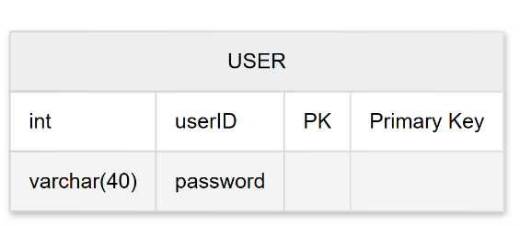
2. Table: Train Maintains the schedule of available trains
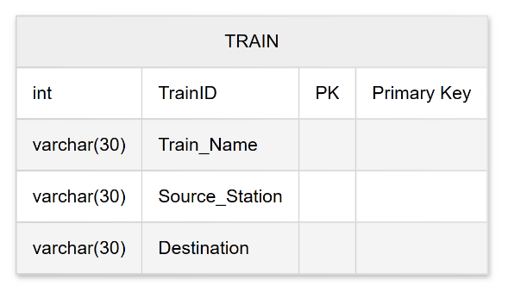
3. Table: Passenger Contains demographic information for passengers.
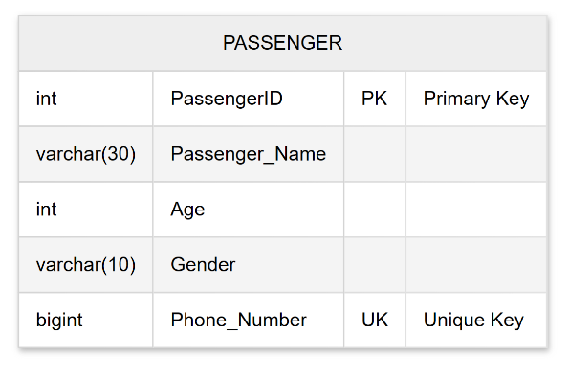
4. Table: Booking The core transactional table linking trains and passengers.
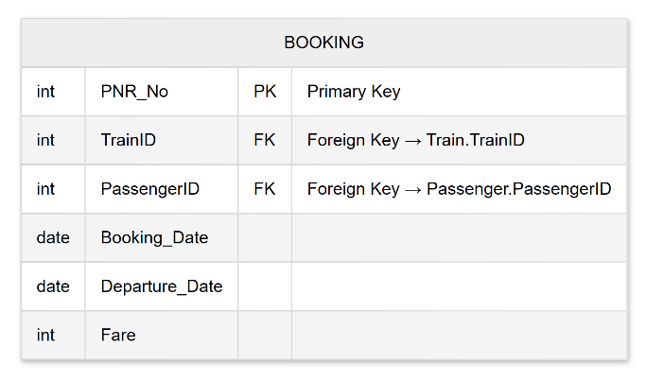

5. Table: Cancellation Logs all cancelled tickets and their associated refunds.
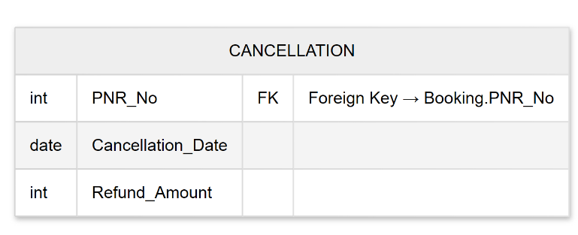

7.2 Relationships
The database utilizes a Star Schema approach where the Booking table acts as the central fact table.
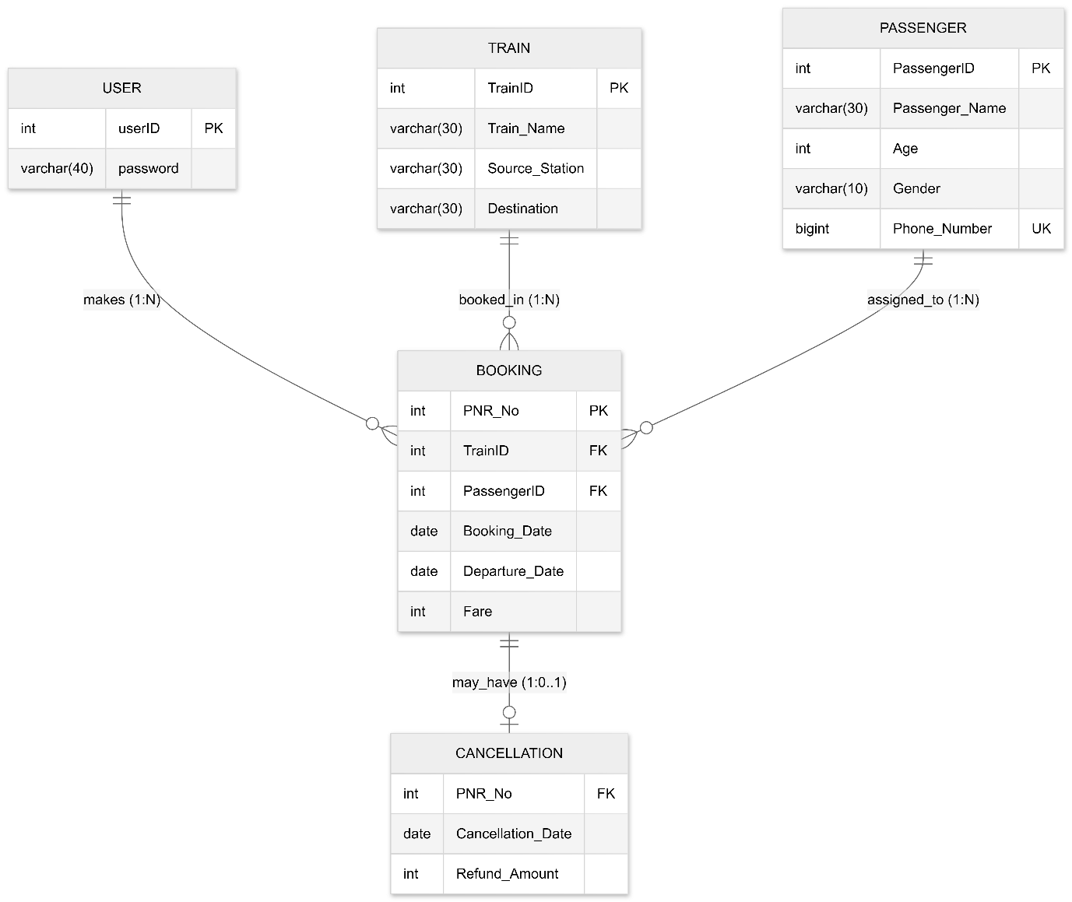
Figure 12: : Database Schema Diagram
- One-to-Many (Train to Booking): One train can have multiple associated bookings, but a single PNR belongs to only one train.
- One-to-Many (Passenger to Booking): A single passenger can book multiple tickets over time.
- One-to-One / Extension (Booking to Cancellation): When a ticket is cancelled, the PNR is used as a reference to calculate the refund, ensuring that only valid existing bookings can be processed for cancellation.

7.3 Sample Records
Below is a representation of how data is populated within the system:
Sample: Train
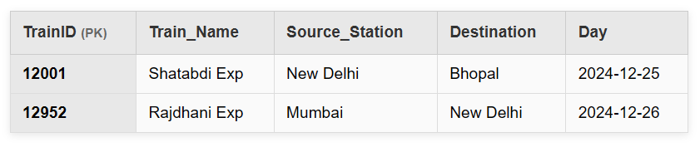
Sample: Booking
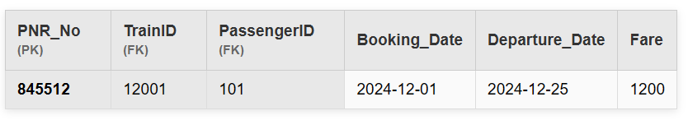
Sample: Cancellation
